**prathamesh@PRATHAMESH:~$ jps**

420 ResourceManager

1109 DataNode

951 NameNode

1368 SecondaryNameNode

18520 Jps

1692 NodeManager

2862 org.eclipse.equinox.launcher_1.6.800.v20240304-1850.jar

**prathamesh@PRATHAMESH:~$ mkdir practical_b2**

**prathamesh@PRATHAMESH:~$ cd practical_b2/**

**prathamesh@PRATHAMESH:~/practical_b2$ ls**

**prathamesh@PRATHAMESH:~/practical_b2$ sudo nano LogCount.java**

[sudo] password for prathamesh:

**prathamesh@PRATHAMESH:~/practical_b2$ cat LogCount.java**

import java.io.IOException;

import java.util.*;

import org.apache.hadoop.fs.Path;

import org.apache.hadoop.conf.*;

import org.apache.hadoop.io.*;

import org.apache.hadoop.mapred.*;

import org.apache.hadoop.util.*;

public class LogCount {

public static class Map extends MapReduceBase implements Mapper<LongWritable, Text, Text, IntWritable> {

private final static IntWritable one = new IntWritable(1);

public void map(LongWritable key, Text value, OutputCollector<Text, IntWritable> output, Reporter reporter)

throws IOException {

String valueString = value.toString();

String[] SingleCountryData = valueString.split("-");

output.collect(new Text(SingleCountryData[0]), one);

}

}

public static class Reduce extends MapReduceBase implements Reducer<Text, IntWritable, Text, IntWritable> {

public void reduce(Text t_key, Iterator<IntWritable> values, OutputCollector<Text, IntWritable> output,

Reporter reporter) throws IOException {

Text key = t_key;

int frequencyForCountry = 0;

while (values.hasNext()) {

// replace type of value with the actual type of our value

IntWritable value = (IntWritable) values.next();

frequencyForCountry += value.get();

}

output.collect(key, new IntWritable(frequencyForCountry));

}

}

public static void main(String[] args) {

JobClient my_client = new JobClient();

// Create a configuration object for the job

JobConf job_conf = new JobConf(LogCount.class);

// Set a name of the Job

job_conf.setJobName("SalePerCountry");

// Specify data type of output key and value

job_conf.setOutputKeyClass(Text.class);

job_conf.setOutputValueClass(IntWritable.class);

// Specify names of Mapper and Reducer Class

job_conf.setMapperClass(LogCount.Map.class);

job_conf.setReducerClass(LogCount.Reduce.class);

// Specify formats of the data type of Input and output

job_conf.setInputFormat(TextInputFormat.class);

job_conf.setOutputFormat(TextOutputFormat.class);

// Set input and output directories using command line arguments,

// arg[0] = name of input directory on HDFS, and arg[1] = name of output

// directory to be created to store the output file.

FileInputFormat.setInputPaths(job_conf, new Path(args[0]));

FileOutputFormat.setOutputPath(job_conf, new Path(args[1]));

my_client.setConf(job_conf);

try {

// Run the job

JobClient.runJob(job_conf);

} catch (Exception e) {

e.printStackTrace();

}

}

}

The above command creates a **practical_b2** folder with **LogCount.java** file containing above code

**prathamesh@PRATHAMESH:~/practical_b2$ mkdir classes**

**prathamesh@PRATHAMESH:~/practical_b2$ javac -cp $(hadoop classpath) -d classes/ LogCount.java**

**prathamesh@PRATHAMESH:~/practical_b2$ jar -cvf logcount.jar -C classes/ .**

added manifest

adding: LogCount$Reduce.class(in = 1614) (out= 660)(deflated 59%)

adding: LogCount.class(in = 1667) (out= 856)(deflated 48%)

adding: LogCount$Map.class(in = 1743) (out= 669)(deflated 61%)

The above command creates a **logcount.jar** file of the Java code we Written

**prathamesh@PRATHAMESH:~/practical_b2$ sudo nano log_data.txt**

**prathamesh@PRATHAMESH:~/practical_b2$ cat log_data.txt**

10.223.157.186 - - [15/Jul/2009:20:50:32 -0700] "GET /assets/js/the-associates.js HTTP/1.1" 304 -

10.223.157.186 - - [15/Jul/2009:20:50:33 -0700] "GET /assets/img/home-logo.png HTTP/1.1" 304 -

10.223.157.186 - - [15/Jul/2009:20:50:33 -0700] "GET /assets/img/dummy/primary-news-2.jpg HTTP/1.1" 304 -

10.223.157.186 - - [15/Jul/2009:20:50:33 -0700] "GET /assets/img/dummy/primary-news-1.jpg HTTP/1.1" 304 -

10.223.157.186 - - [15/Jul/2009:20:50:33 -0700] "GET /assets/img/home-media-block-placeholder.jpg HTTP/1.1" 304 -

10.223.157.186 - - [15/Jul/2009:20:50:33 -0700] "GET /assets/img/dummy/secondary-news-4.jpg HTTP/1.1" 304 -

10.223.157.186 - - [15/Jul/2009:20:50:33 -0700] "GET /assets/img/loading.gif HTTP/1.1" 304 -

10.223.157.186 - - [15/Jul/2009:20:50:33 -0700] "GET /assets/img/search-button.gif HTTP/1.1" 304 -

10.223.157.186 - - [15/Jul/2009:20:50:33 -0700] "GET /assets/img/dummy/secondary-news-3.jpg HTTP/1.1" 304 -

10.223.157.186 - - [15/Jul/2009:20:50:33 -0700] "GET /assets/img/dummy/secondary-news-2.jpg HTTP/1.1" 304 -

10.223.157.186 - - [15/Jul/2009:20:50:33 -0700] "GET /assets/img/dummy/secondary-news-1.jpg HTTP/1.1" 304 -

10.216.113.172 - - [16/Jul/2009:02:51:31 -0700] "GET /assets/img/closelabel.gif HTTP/1.1" 200 979

10.216.113.172 - - [16/Jul/2009:02:51:31 -0700] "GET /favicon.ico HTTP/1.1" 404 209

10.216.113.172 - - [16/Jul/2009:02:51:31 -0700] "GET /assets/swf/home-media-block.swf HTTP/1.1" 200 123884

10.216.113.172 - - [16/Jul/2009:02:51:41 -0700] "GET /films/district-13 HTTP/1.1" 301 268

10.216.113.172 - - [16/Jul/2009:02:51:41 -0700] "GET /films/district-13/ HTTP/1.1" 200 12772

10.216.113.172 - - [16/Jul/2009:02:51:41 -0700] "GET /assets/img/pdf-icon.gif HTTP/1.1" 200 228

10.216.113.172 - - [16/Jul/2009:02:51:41 -0700] "GET /assets/img/dummy/momentum-pictures-logo.gif HTTP/1.1" 200 3579

10.216.113.172 - - [16/Jul/2009:02:51:41 -0700] "GET /assets/img/dummy/films/district-13/image-thumbs/1.jpg HTTP/1.1" 200 9276

10.216.113.172 - - [16/Jul/2009:02:51:41 -0700] "GET /assets/img/dummy/films/district-13/image-thumbs/4.jpg HTTP/1.1" 200 10011

10.216.113.172 - - [16/Jul/2009:02:51:42 -0700] "GET /assets/img/download-icon.gif HTTP/1.1" 200 71

10.216.113.172 - - [16/Jul/2009:02:51:42 -0700] "GET /assets/img/dummy/films/district-13/image-thumbs/3.jpg HTTP/1.1" 200 9040

10.216.113.172 - - [16/Jul/2009:02:51:41 -0700] "GET /assets/img/dummy/film-page-media.jpg HTTP/1.1" 200 110997

10.216.113.172 - - [16/Jul/2009:02:51:42 -0700] "GET /assets/img/dummy/films/district-13/image-thumbs/2.jpg HTTP/1.1" 200 9626

10.82.30.199 - - [16/Jul/2009:03:00:06 -0700] "GET / HTTP/1.1" 200 7616

10.82.30.199 - - [16/Jul/2009:03:00:06 -0700] "GET /assets/css/960.css HTTP/1.1" 200 6206

10.82.30.199 - - [16/Jul/2009:03:00:06 -0700] "GET /assets/css/reset.css HTTP/1.1" 200 1014

10.82.30.199 - - [16/Jul/2009:03:00:06 -0700] "GET /assets/js/lowpro.js HTTP/1.1" 200 10469

10.82.30.199 - - [16/Jul/2009:03:00:06 -0700] "GET /assets/css/the-associates.css HTTP/1.1" 200 15779

10.82.30.199 - - [16/Jul/2009:03:00:06 -0700] "GET /assets/js/the-associates.js HTTP/1.1" 200 4492

10.82.30.199 - - [16/Jul/2009:03:00:06 -0700] "GET /assets/js/lightbox.js HTTP/1.1" 200 25960

10.82.30.199 - - [16/Jul/2009:03:00:07 -0700] "GET /assets/img/home-logo.png HTTP/1.1" 200 3892

10.82.30.199 - - [16/Jul/2009:03:00:07 -0700] "GET /assets/img/dummy/secondary-news-3.jpg HTTP/1.1" 200 5604

10.82.30.199 - - [16/Jul/2009:03:00:07 -0700] "GET /assets/img/dummy/primary-news-1.jpg HTTP/1.1" 200 10556

10.82.30.199 - - [16/Jul/2009:03:00:07 -0700] "GET /assets/img/dummy/secondary-news-4.jpg HTTP/1.1" 200 5766

10.82.30.199 - - [16/Jul/2009:03:00:07 -0700] "GET /assets/img/dummy/primary-news-2.jpg HTTP/1.1" 200 9925

10.82.30.199 - - [16/Jul/2009:03:00:07 -0700] "GET /assets/img/dummy/secondary-news-1.jpg HTTP/1.1" 200 5766

10.82.30.199 - - [16/Jul/2009:03:00:55 -0700] "GET /about-us/ HTTP/1.1" 200 6992

10.82.30.199 - - [16/Jul/2009:03:00:57 -0700] "GET /release-schedule HTTP/1.1" 301 267

10.82.30.199 - - [16/Jul/2009:03:00:57 -0700] "GET /release-schedule/ HTTP/1.1" 200 11368

10.82.30.199 - - [16/Jul/2009:03:00:58 -0700] "GET /trailers HTTP/1.1" 301 259

10.82.30.199 - - [16/Jul/2009:03:00:59 -0700] "GET /trailers/ HTTP/1.1" 200 11508

10.82.30.199 - - [16/Jul/2009:03:01:01 -0700] "GET /release-schedule/ HTTP/1.1" 200 11368

10.216.113.172 - - [16/Jul/2009:03:14:59 -0700] "GET / HTTP/1.1" 200 7616

10.216.113.172 - - [16/Jul/2009:03:14:59 -0700] "GET /favicon.ico HTTP/1.1" 404 209

10.216.113.172 - - [16/Jul/2009:03:14:59 -0700] "GET /assets/css/reset.css HTTP/1.1" 200 1014

10.216.113.172 - - [16/Jul/2009:03:14:59 -0700] "GET /assets/css/960.css HTTP/1.1" 200 6206

10.216.113.172 - - [16/Jul/2009:03:14:59 -0700] "GET /assets/css/the-associates.css HTTP/1.1" 200 15779

10.216.113.172 - - [16/Jul/2009:03:15:01 -0700] "GET /assets/js/lowpro.js HTTP/1.1" 200 10469

10.216.113.172 - - [16/Jul/2009:03:15:01 -0700] "GET /assets/js/lightbox.js HTTP/1.1" 200 25960

10.216.113.172 - - [16/Jul/2009:03:15:01 -0700] "GET /assets/js/the-associates.js HTTP/1.1" 200 4492

10.216.113.172 - - [16/Jul/2009:03:15:02 -0700] "GET /assets/img/search-button.gif HTTP/1.1" 200 168

10.216.113.172 - - [16/Jul/2009:03:15:02 -0700] "GET /assets/img/dummy/primary-news-1.jpg HTTP/1.1" 200 10556

10.216.113.172 - - [16/Jul/2009:03:15:02 -0700] "GET /assets/img/dummy/primary-news-2.jpg HTTP/1.1" 200 9925

10.216.113.172 - - [16/Jul/2009:03:15:17 -0700] "GET /assets/img/trailers-logo.png HTTP/1.1" 200 3764

10.216.113.172 - - [16/Jul/2009:03:15:20 -0700] "GET /release-schedule HTTP/1.1" 301 267

10.216.113.172 - - [16/Jul/2009:03:15:20 -0700] "GET /release-schedule/ HTTP/1.1" 200 11368

10.216.113.172 - - [16/Jul/2009:03:15:20 -0700] "GET /assets/img/release-schedule-logo.png HTTP/1.1" 200 3704

10.216.113.172 - - [16/Jul/2009:03:15:22 -0700] "GET /about-us HTTP/1.1" 301 259

10.216.113.172 - - [16/Jul/2009:03:15:23 -0700] "GET /about-us/ HTTP/1.1" 200 6992

10.216.113.172 - - [16/Jul/2009:03:15:23 -0700] "GET /assets/img/about-us-logo.png HTTP/1.1" 200 3702

10.216.113.172 - - [16/Jul/2009:03:15:23 -0700] "GET /assets/img/dummy/about-us.jpg HTTP/1.1" 200 21162

10.207.190.45 - - [16/Jul/2009:04:14:59 -0700] "GET / HTTP/1.1" 200 7616

10.207.190.45 - - [16/Jul/2009:04:14:59 -0700] "GET /favicon.ico HTTP/1.1" 404 209

10.207.190.45 - - [16/Jul/2009:04:14:59 -0700] "GET /assets/css/reset.css HTTP/1.1" 200 1014

10.207.190.45 - - [16/Jul/2009:04:14:59 -0700] "GET /assets/css/960.css HTTP/1.1" 200 6206

10.207.190.45 - - [16/Jul/2009:04:14:59 -0700] "GET /assets/js/the-associates.js HTTP/1.1" 200 4492

10.207.190.45 - - [16/Jul/2009:04:14:59 -0700] "GET /assets/js/lowpro.js HTTP/1.1" 200 10469

10.207.190.45 - - [16/Jul/2009:04:14:59 -0700] "GET /assets/js/lightbox.js HTTP/1.1" 200 25960

10.207.190.45 - - [16/Jul/2009:04:14:59 -0700] "GET /assets/css/the-associates.css HTTP/1.1" 200 15779

10.207.190.45 - - [16/Jul/2009:04:15:00 -0700] "GET /assets/img/search-button.gif HTTP/1.1" 200 168

10.207.190.45 - - [16/Jul/2009:04:15:00 -0700] "GET /assets/img/dummy/secondary-news-3.jpg HTTP/1.1" 200 5604

10.207.190.45 - - [16/Jul/2009:04:15:00 -0700] "GET /assets/img/dummy/secondary-news-4.jpg HTTP/1.1" 200 5766

10.207.190.45 - - [16/Jul/2009:04:15:00 -0700] "GET /assets/img/home-logo.png HTTP/1.1" 200 3892

10.207.190.45 - - [16/Jul/2009:04:15:00 -0700] "GET /assets/img/loading.gif HTTP/1.1" 200 2767

10.207.190.45 - - [16/Jul/2009:04:15:00 -0700] "GET /assets/img/closelabel.gif HTTP/1.1" 200 979

10.207.190.45 - - [16/Jul/2009:04:15:00 -0700] "GET /assets/img/home-media-block-placeholder.jpg HTTP/1.1" 200 68831

10.207.190.45 - - [16/Jul/2009:04:15:00 -0700] "GET /assets/swf/home-media-block.swf HTTP/1.1" 200 123884

10.207.190.45 - - [16/Jul/2009:04:15:02 -0700] "GET /favicon.ico HTTP/1.1" 404 209

10.216.113.172 - - [28/Jul/2009:06:48:19 -0700] "GET / HTTP/1.1" 200 7616

10.216.113.172 - - [28/Jul/2009:06:48:19 -0700] "GET /assets/js/lowpro.js HTTP/1.1" 200 10469

10.216.113.172 - - [28/Jul/2009:06:48:19 -0700] "GET /assets/css/960.css HTTP/1.1" 200 6206

10.216.113.172 - - [28/Jul/2009:06:48:20 -0700] "GET /assets/css/reset.css HTTP/1.1" 200 1014

10.216.113.172 - - [28/Jul/2009:06:48:19 -0700] "GET /assets/css/the-associates.css HTTP/1.1" 200 15779

10.216.113.172 - - [28/Jul/2009:06:48:20 -0700] "GET /assets/js/the-associates.js HTTP/1.1" 200 4492

10.216.113.172 - - [28/Jul/2009:06:48:20 -0700] "GET /assets/js/lightbox.js HTTP/1.1" 200 25960

10.216.113.172 - - [28/Jul/2009:06:48:20 -0700] "GET /assets/img/closelabel.gif HTTP/1.1" 200 979

10.216.113.172 - - [28/Jul/2009:06:48:20 -0700] "GET /assets/img/dummy/primary-news-1.jpg HTTP/1.1" 200 10556

10.216.113.172 - - [28/Jul/2009:06:56:54 -0700] "GET /assets/swf/media-player.swf HTTP/1.1" 200 34573

10.216.113.172 - - [28/Jul/2009:06:56:54 -0700] "GET /assets/flv/dummy/home-media-block/district-13.flv HTTP/1.1" 200 24333581

10.216.113.172 - - [28/Jul/2009:06:58:33 -0700] "GET /assets/img/dummy/films/district-13/images/1.jpg HTTP/1.1" 200 84400

10.216.113.172 - - [28/Jul/2009:06:58:34 -0700] "GET /assets/img/dummy/films/district-13/images/2.jpg HTTP/1.1" 200 127021

10.216.113.172 - - [28/Jul/2009:06:58:38 -0700] "GET /assets/img/nextlabel.gif HTTP/1.1" 200 1252

10.216.113.172 - - [28/Jul/2009:06:58:40 -0700] "GET /assets/img/dummy/films/district-13/images/3.jpg HTTP/1.1" 200 113131

10.82.30.199 - - [28/Jul/2009:08:58:47 -0700] "GET / HTTP/1.1" 200 7616

10.82.30.199 - - [28/Jul/2009:08:58:47 -0700] "GET /assets/css/960.css HTTP/1.1" 200 6206

10.82.30.199 - - [28/Jul/2009:08:58:47 -0700] "GET /assets/js/lowpro.js HTTP/1.1" 200 10469

10.82.30.199 - - [28/Jul/2009:08:58:47 -0700] "GET /assets/css/reset.css HTTP/1.1" 200 1014

10.82.30.199 - - [28/Jul/2009:08:58:47 -0700] "GET /assets/css/the-associates.css HTTP/1.1" 200 15779

10.82.30.199 - - [28/Jul/2009:08:58:47 -0700] "GET /assets/js/the-associates.js HTTP/1.1" 200 4492

10.82.30.199 - - [28/Jul/2009:08:58:47 -0700] "GET /assets/js/lightbox.js HTTP/1.1" 200 25960

10.82.30.199 - - [28/Jul/2009:08:58:48 -0700] "GET /assets/img/dummy/secondary-news-1.jpg HTTP/1.1" 200 5766

10.82.30.199 - - [28/Jul/2009:08:58:48 -0700] "GET /assets/img/search-button.gif HTTP/1.1" 200 168

10.82.30.199 - - [28/Jul/2009:08:58:48 -0700] "GET /assets/img/home-logo.png HTTP/1.1" 200 3892

10.82.30.199 - - [28/Jul/2009:08:58:48 -0700] "GET /assets/img/dummy/primary-news-2.jpg HTTP/1.1" 200 9925

10.82.30.199 - - [28/Jul/2009:08:58:48 -0700] "GET /assets/img/dummy/primary-news-1.jpg HTTP/1.1" 200 10556

The above command creates a **log_data.txt** file containing above logs

**prathamesh@PRATHAMESH:~/practical_b2$ hadoop fs -mkdir -p /logcount/input /logcount/output**

2024-05-05 14:49:48,565 WARN util.NativeCodeLoader: Unable to load native-hadoop library for your platform... using builtin-java classes where applicable

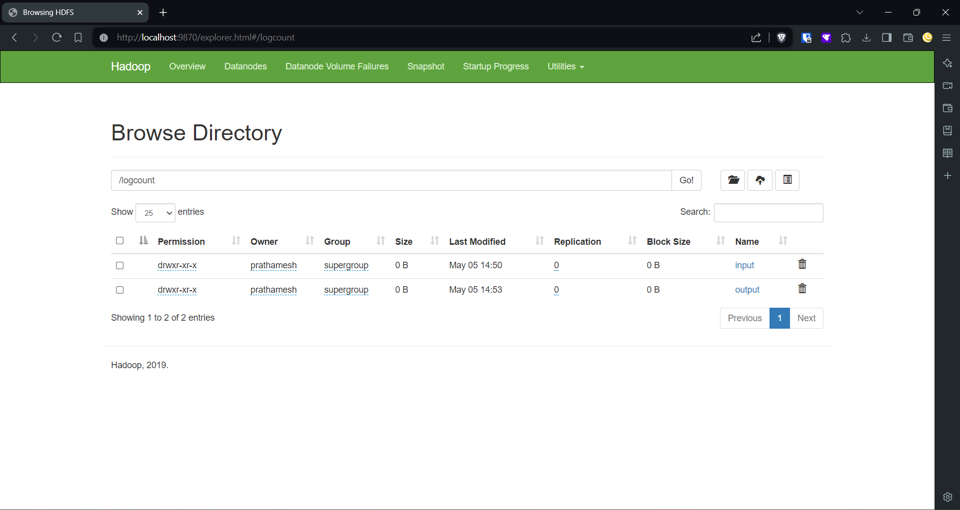

**prathamesh@PRATHAMESH:~/practical_b2$ hadoop fs -put log_data.txt /logcount/input/**

2024-05-05 14:50:52,215 WARN util.NativeCodeLoader: Unable to load native-hadoop library for your platform... using builtin-java classes where applicable

2024-05-05 14:50:53,497 INFO sasl.SaslDataTransferClient: SASL encryption trust check: localHostTrusted = false, remoteHostTrusted = false

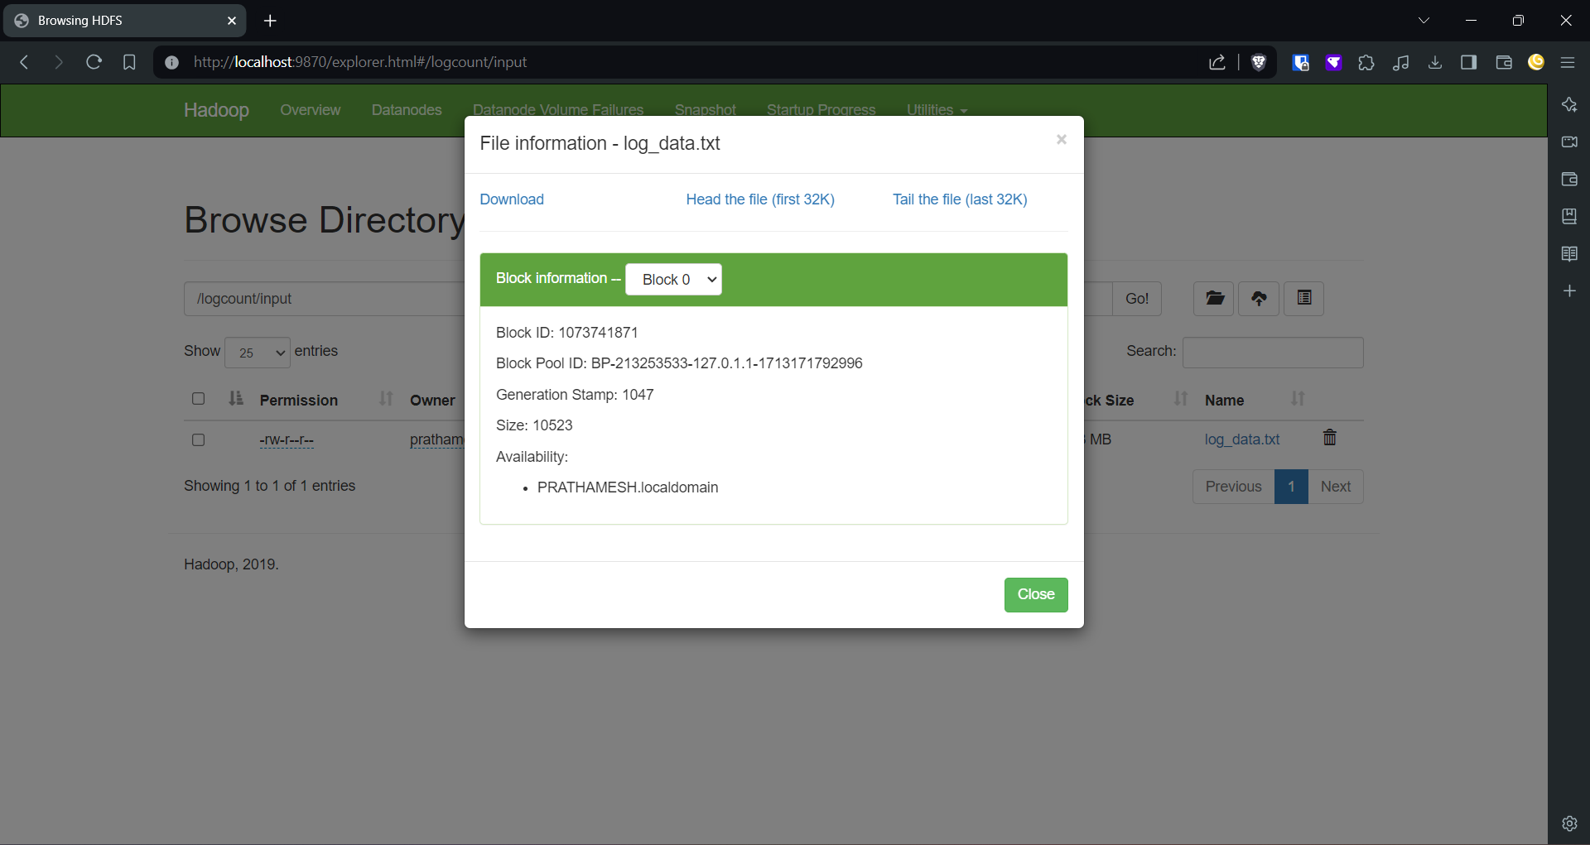

The above commands creates a **logcount** folder with subfolders **input & output** and copy **log_data.txt** file to **Hadoop file system**

**prathamesh@PRATHAMESH:~/practical_b2$ hadoop jar logcount.jar LogCount /logcount/input/log_data.txt /logcount/output/op**

The above command is the code command of practical which executes the code and create **op** folder in **output** folder with files containing the output

2024-05-05 14:52:48,724 WARN util.NativeCodeLoader: Unable to load native-hadoop library for your platform... using builtin-java classes where applicable

2024-05-05 14:52:49,455 INFO client.RMProxy: Connecting to ResourceManager at localhost/127.0.0.1:8032

2024-05-05 14:52:49,893 INFO client.RMProxy: Connecting to ResourceManager at localhost/127.0.0.1:8032

2024-05-05 14:52:50,274 WARN mapreduce.JobResourceUploader: Hadoop command-line option parsing not performed. Implement the Tool interface and execute your application with ToolRunner to remedy this.

2024-05-05 14:52:50,317 INFO mapreduce.JobResourceUploader: Disabling Erasure Coding for path: /tmp/hadoop-yarn/staging/prathamesh/.staging/job_1714897168993_0004

2024-05-05 14:52:50,470 INFO sasl.SaslDataTransferClient: SASL encryption trust check: localHostTrusted = false, remoteHostTrusted = false

2024-05-05 14:52:50,796 INFO mapred.FileInputFormat: Total input files to process : 1

2024-05-05 14:52:50,873 INFO sasl.SaslDataTransferClient: SASL encryption trust check: localHostTrusted = false, remoteHostTrusted = false

2024-05-05 14:52:51,327 INFO sasl.SaslDataTransferClient: SASL encryption trust check: localHostTrusted = false, remoteHostTrusted = false

2024-05-05 14:52:51,753 INFO mapreduce.JobSubmitter: number of splits:2

2024-05-05 14:52:52,064 INFO sasl.SaslDataTransferClient: SASL encryption trust check: localHostTrusted = false, remoteHostTrusted = false

2024-05-05 14:52:52,096 INFO mapreduce.JobSubmitter: Submitting tokens for job: job_1714897168993_0004

2024-05-05 14:52:52,096 INFO mapreduce.JobSubmitter: Executing with tokens: []

2024-05-05 14:52:52,423 INFO conf.Configuration: resource-types.xml not found

2024-05-05 14:52:52,424 INFO resource.ResourceUtils: Unable to find 'resource-types.xml'.

2024-05-05 14:52:53,096 INFO impl.YarnClientImpl: Submitted application application_1714897168993_0004

2024-05-05 14:52:53,190 INFO mapreduce.Job: The url to track the job: http://PRATHAMESH.localdomain:8088/proxy/application_1714897168993_0004/

2024-05-05 14:52:53,195 INFO mapreduce.Job: Running job: job_1714897168993_0004

2024-05-05 14:53:04,683 INFO mapreduce.Job: Job job_1714897168993_0004 running in uber mode : false

2024-05-05 14:53:04,689 INFO mapreduce.Job: map 0% reduce 0%

2024-05-05 14:53:19,498 INFO mapreduce.Job: map 100% reduce 0%

2024-05-05 14:53:27,589 INFO mapreduce.Job: map 100% reduce 100%

2024-05-05 14:53:28,612 INFO mapreduce.Job: Job job_1714897168993_0004 completed successfully

2024-05-05 14:53:28,990 INFO mapreduce.Job: Counters: 54

File System Counters

FILE: Number of bytes read=2259

FILE: Number of bytes written=682583

FILE: Number of read operations=0

FILE: Number of large read operations=0

FILE: Number of write operations=0

HDFS: Number of bytes read=14821

HDFS: Number of bytes written=73

HDFS: Number of read operations=11

HDFS: Number of large read operations=0

HDFS: Number of write operations=2

HDFS: Number of bytes read erasure-coded=0

Job Counters

Launched map tasks=2

Launched reduce tasks=1

Data-local map tasks=2

Total time spent by all maps in occupied slots (ms)=24676

Total time spent by all reduces in occupied slots (ms)=5492

Total time spent by all map tasks (ms)=24676

Total time spent by all reduce tasks (ms)=5492

Total vcore-milliseconds taken by all map tasks=24676

Total vcore-milliseconds taken by all reduce tasks=5492

Total megabyte-milliseconds taken by all map tasks=25268224

Total megabyte-milliseconds taken by all reduce tasks=5623808

Map-Reduce Framework

Map input records=106

Map output records=106

Map output bytes=2041

Map output materialized bytes=2265

Input split bytes=202

Combine input records=0

Combine output records=0

Reduce input groups=4

Reduce shuffle bytes=2265

Reduce input records=106

Reduce output records=4

Spilled Records=212

Shuffled Maps =2

Failed Shuffles=0

Merged Map outputs=2

GC time elapsed (ms)=260

CPU time spent (ms)=9870

Physical memory (bytes) snapshot=732110848

Virtual memory (bytes) snapshot=7694708736

Total committed heap usage (bytes)=596115456

Peak Map Physical memory (bytes)=280907776

Peak Map Virtual memory (bytes)=2562424832

Peak Reduce Physical memory (bytes)=173240320

Peak Reduce Virtual memory (bytes)=2570432512

Shuffle Errors

BAD_ID=0

CONNECTION=0

IO_ERROR=0

WRONG_LENGTH=0

WRONG_MAP=0

WRONG_REDUCE=0

File Input Format Counters

Bytes Read=14619

File Output Format Counters

Bytes Written=73

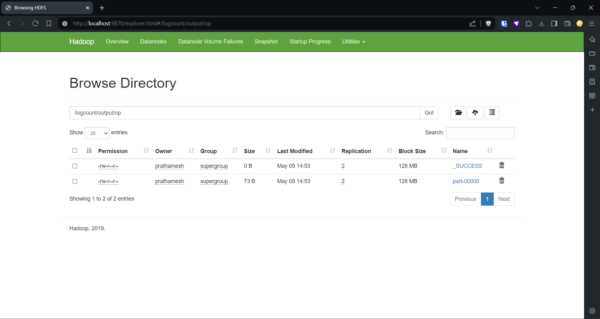

**prathamesh@PRATHAMESH:~/practical_b2$ hadoop fs -ls /logcount/output/op**

2024-05-05 14:53:47,620 WARN util.NativeCodeLoader: Unable to load native-hadoop library for your platform... using builtin-java classes where applicable

Found 2 items

-rw-r--r-- 2 prathamesh supergroup 0 2024-05-05 14:53 /logcount/output/op/_SUCCESS

-rw-r--r-- 2 prathamesh supergroup 73 2024-05-05 14:53 /logcount/output/op/part-00000

**prathamesh@PRATHAMESH:~/practical_b2$ hadoop fs -get /logcount/output/op .**

2024-05-05 14:54:06,385 WARN util.NativeCodeLoader: Unable to load native-hadoop library for your platform... using builtin-java classes where applicable

2024-05-05 14:54:07,309 INFO sasl.SaslDataTransferClient: SASL encryption trust check: localHostTrusted = false, remoteHostTrusted = false

**prathamesh@PRATHAMESH:~/practical_b2$ ls**

LogCount.java classes log_data.txt logcount.jar op

**prathamesh@PRATHAMESH:~/practical_b2$ cat op/part-00000**

10.207.190.45 17

10.216.113.172 47

10.223.157.186 11

10.82.30.199 31

**prathamesh@PRATHAMESH:~/practical_b2$**

The above command to copy output and display it.

**SCREENSHOTS:**

